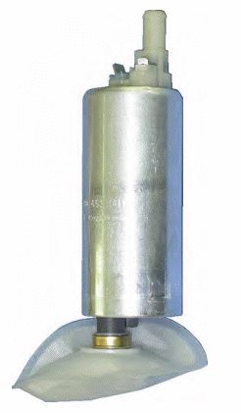 | Fuel Pump  (Fuel Supply System) | 8 15 019  90 411 794  90 442 231 | Astra Corsa  Omega Vectra  Zafira

